**3 - R710 Proxmox Install**

The following steps came from info in document : proxmox – steup notes.txt

(Review it if any of these steps fail) (It covers getting files to create DVD's or USB install, etc)

Steps:

1. Before installing:

Ensure Virtualisation Technology is enabled in bios ...

Enable it, and reboot into bios to check that it is still enabled.

=> if it is not enabled, then do the NVRAM clear process (see other documents)

1. When installing:

May need to adjust initial settings for disc allocation, such that root is a lot less than 60GB and swap is a lot less than 8GB

You will need to provide a valid email address during install, for proxmox to send alerts to.

As the system has previously been set up with RAID 10 for all 4 disks, they will appear as just one disk, namely ‘sda’ for proxmox to install on to.

Click options next to this and select XFS as the file system, (better for parallel stuff & better MongoDB performance with fast SSD's – if used in future)

Configure country.

user: root

password: <whatever>

Use first of 4 ethernet ports for management

Hostname: <whatever> [to reflect the proxmox “node” name]

**NOTE**: The hostname is used in proxmox to hang lots of settings off, and changing  
 it later will break things … so be sure to set it now to what you really want.

IP address 192.168.124.**ppn**

netmask: 255.255.255.0

gateway: 192.168.124.1

DNS: 8.8.8.8

1. After install, log in via Firefox browser on: https://192.168.124.<**ppn**>:8006

Click on Advanced, and then Click on ‘Accept the Risk and Continue’.  
 (warnings due to it using its own self signed certificate)

1. Dark theme: <https://github.com/Weilbyte/PVEDiscordDark>
2. VLAN Aware  
   In Network -> vmbr0 -> Edit ensure VLAN aware is ticked:  
   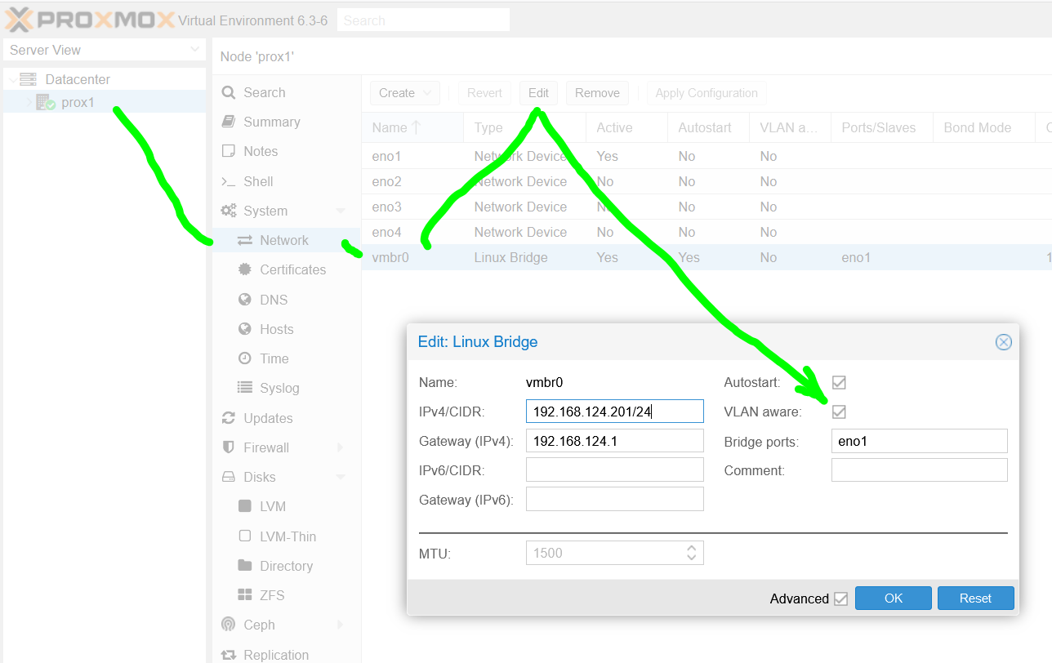  
   and click OK